8. Function Module Packages

Table of Contents

|  |  |  |
| --- | --- | --- |
| Sl. No | Topics | Page No |
| 8.1 | **Standard Libraries** | **2** |
| 8.2 | **Functions** | **3** |
| 8.3 | **Modules** | **17** |
| 8.4 | **Packages** | **29** |

## 8.1 Standard Libraries

**What is Standard Library?**

Standard Library is a collection of tools that come with Python*.* The standard library includes the following:

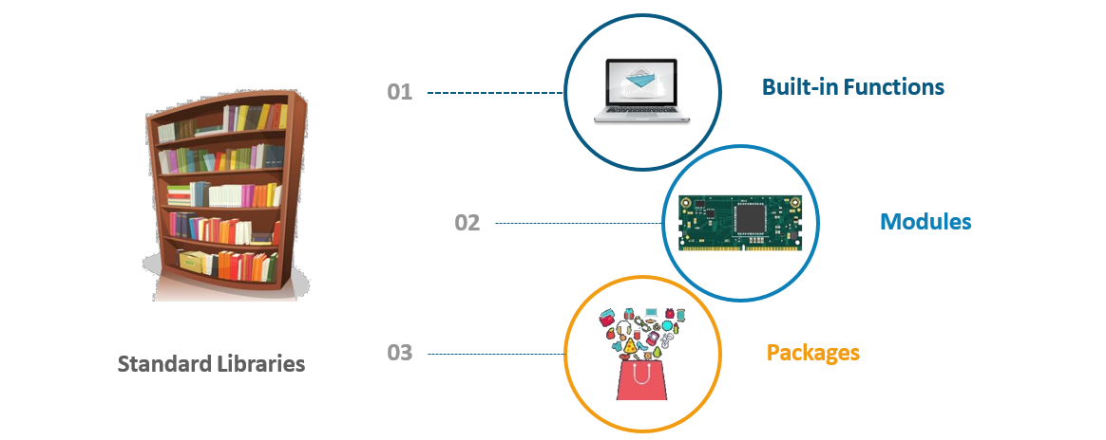

## 8.2 Functions

**Why do we need Functions?**

Developer has to write a program in which he has to calculate ***Factorial*** multiple times

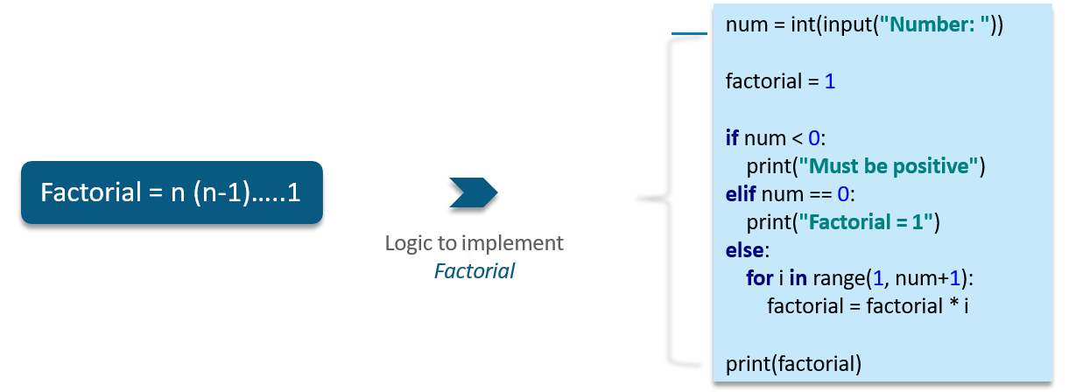

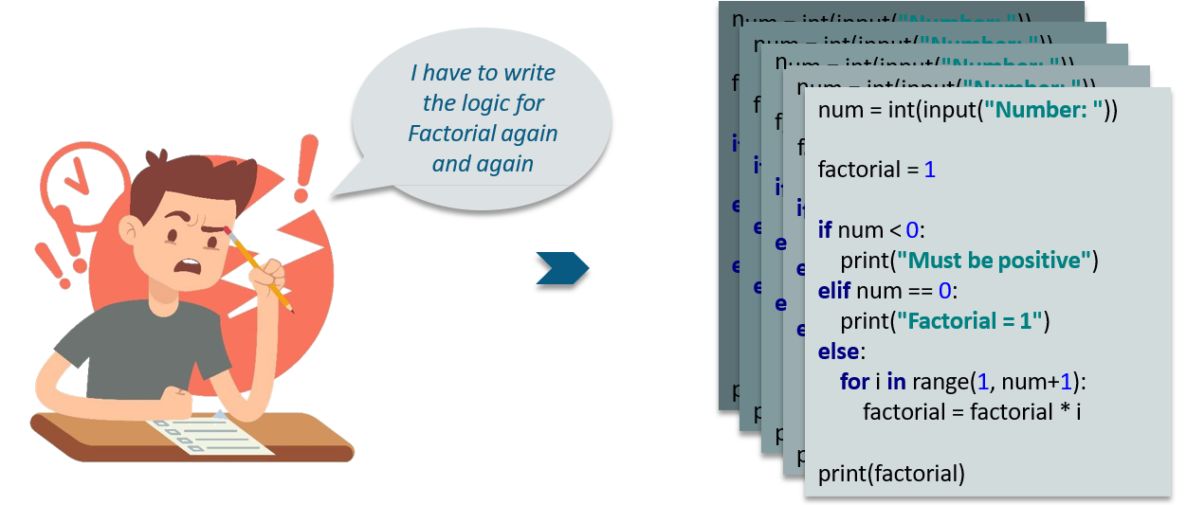

**What are Functions?**

A **Function** is a block of organized, reusable code that is used to perform a single and related action

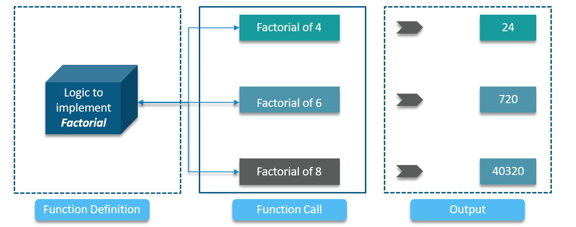

**How do we Define and Call Functions?**

**Function Definition and Function Call**

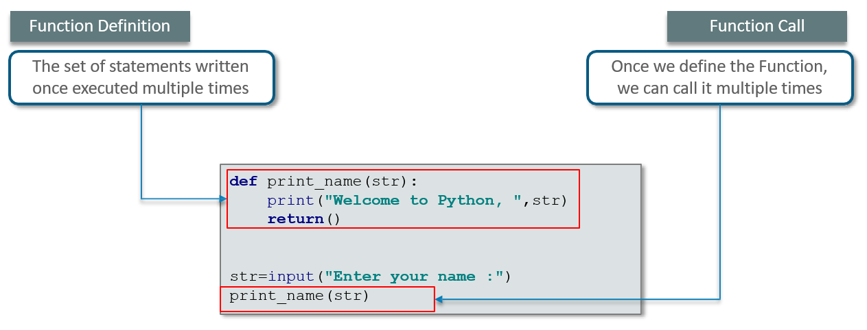

**Why we use the return statement?**

**The Return Statement**

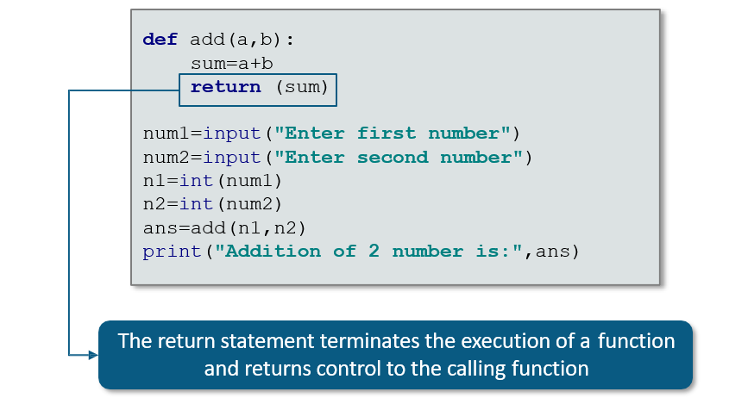

**Concept of name == " main "**

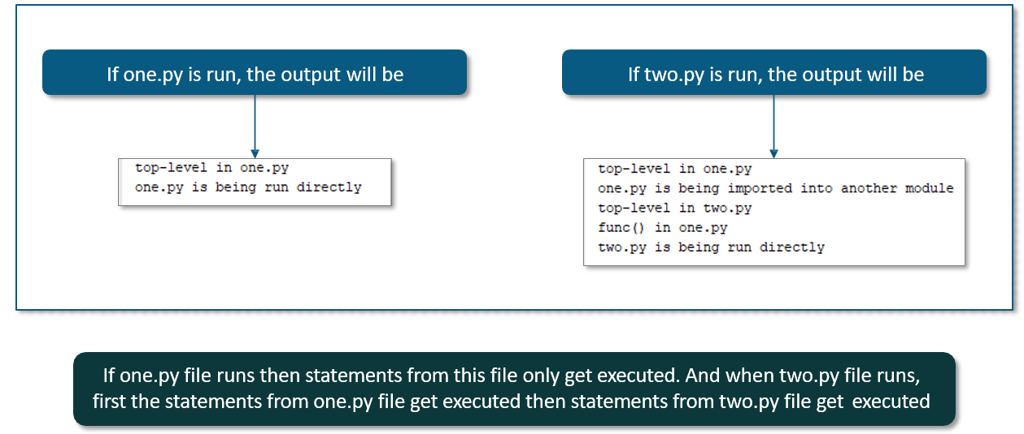

**What are the Built in functions in Python?**

Built-in Functions are the Functions which are built into (already available) Python and can be accessed by end-users:

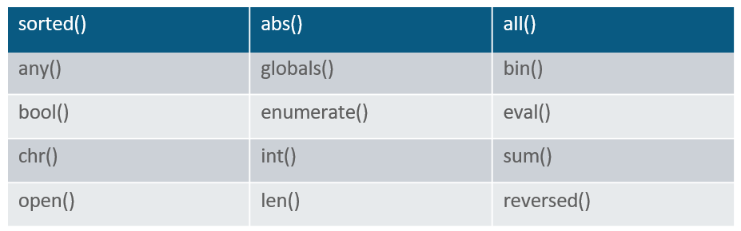

Refer: [https://docs.python.org/3/library/functions.html#eval](https://docs.python.org/3/library/functions.html" \l "eval)

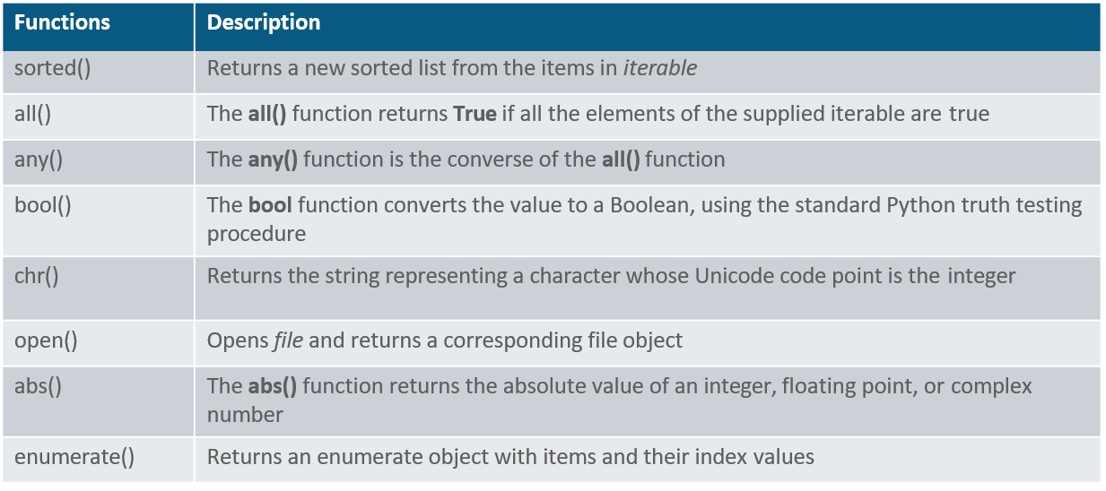

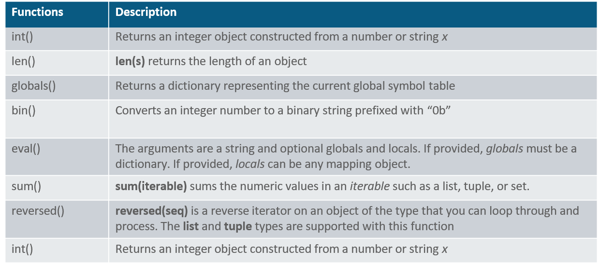

**Important Built-in Function**

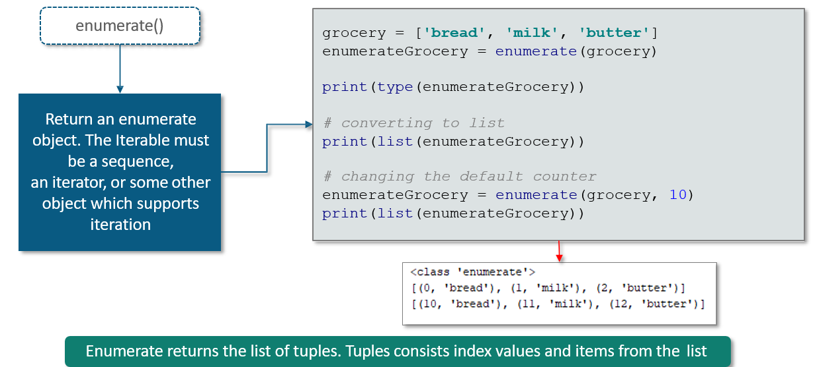

**Example: Functions**

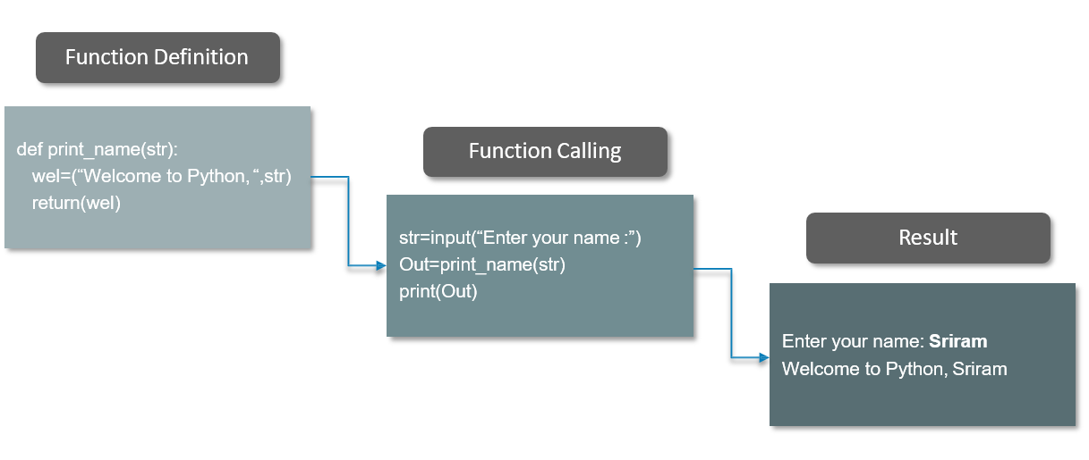

**What is Lambda Function**?

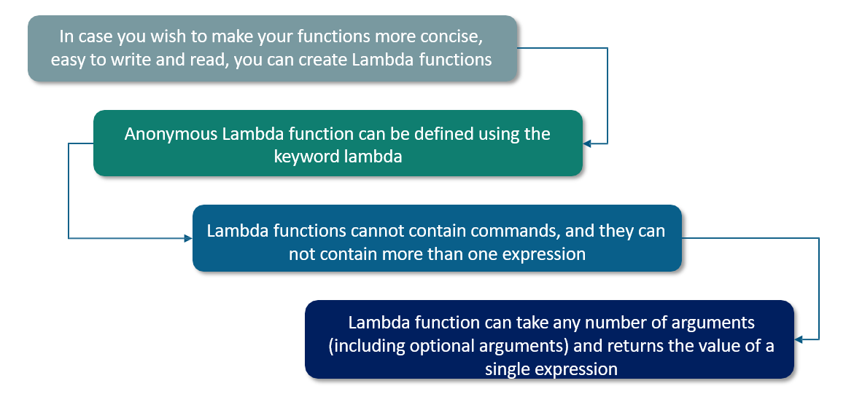

We can use Lambda function when we require a nameless function for short period of time.

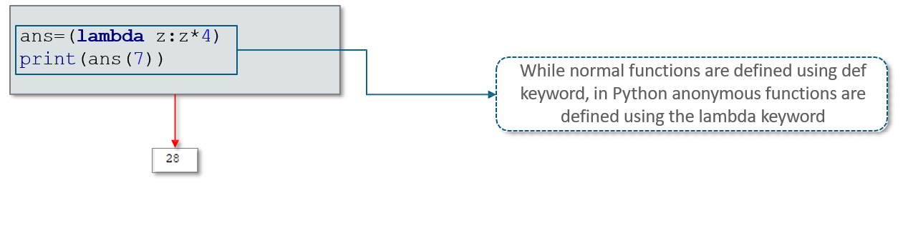

**Map, Filter, Reduce using Lambda** 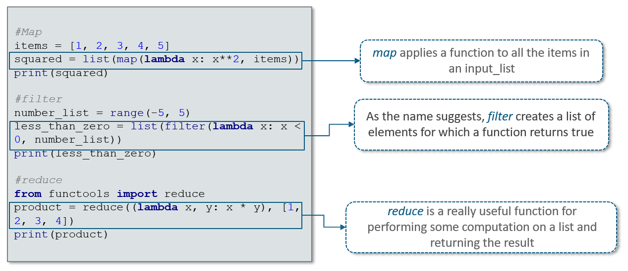

**What is the scope of variable in Python?**

**Global Variables**

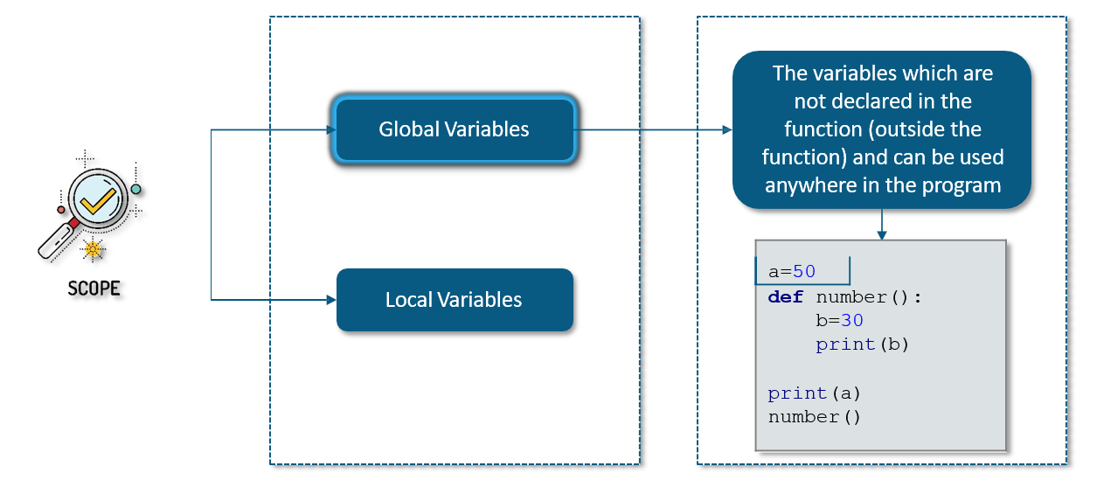

**Local Variables**

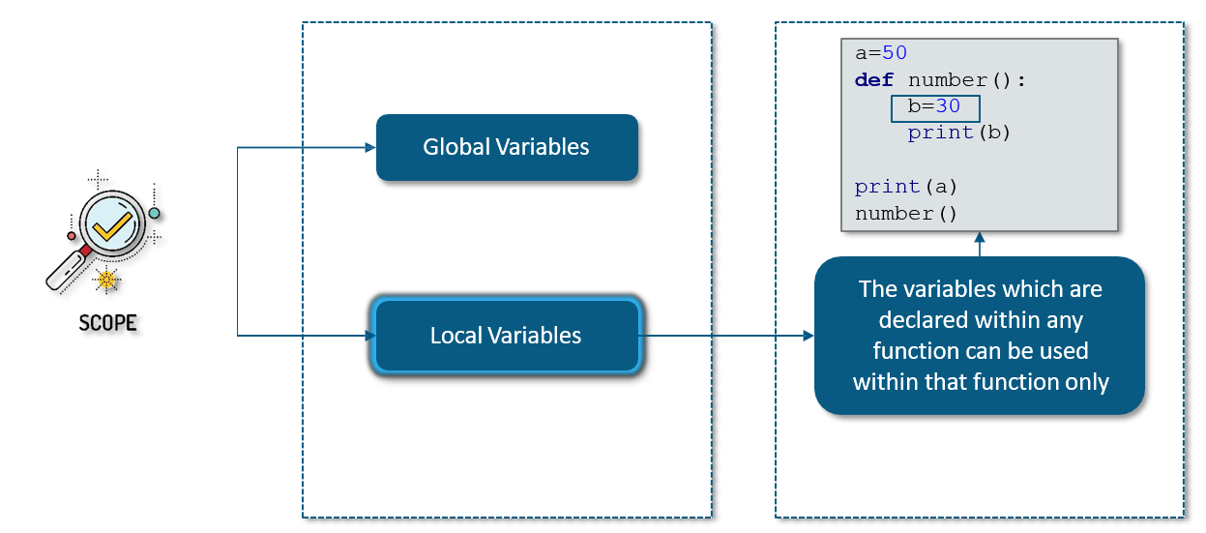

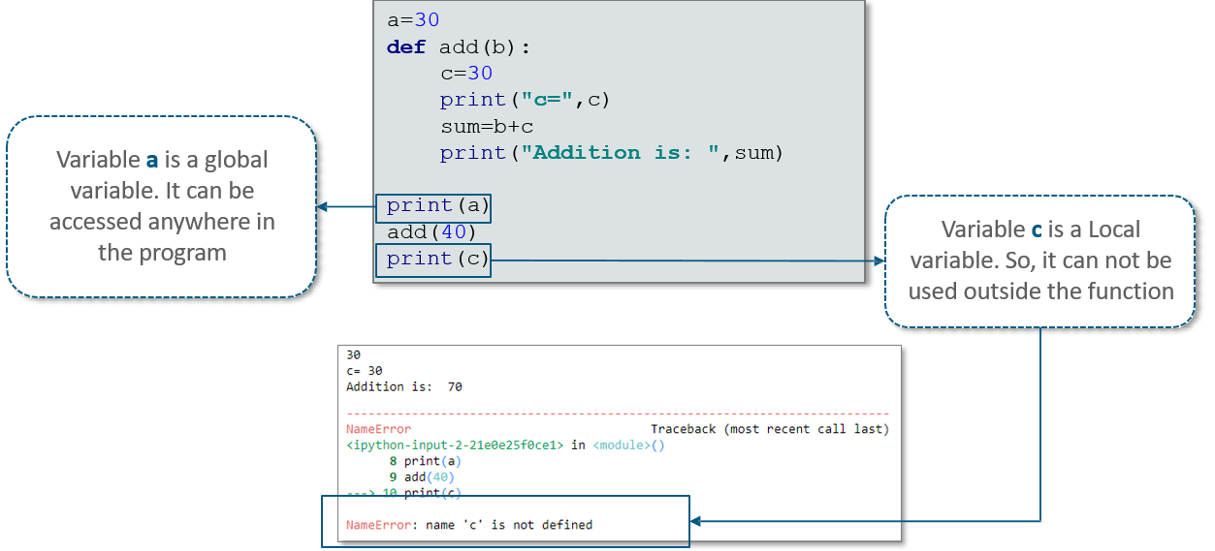

**Memory Address**

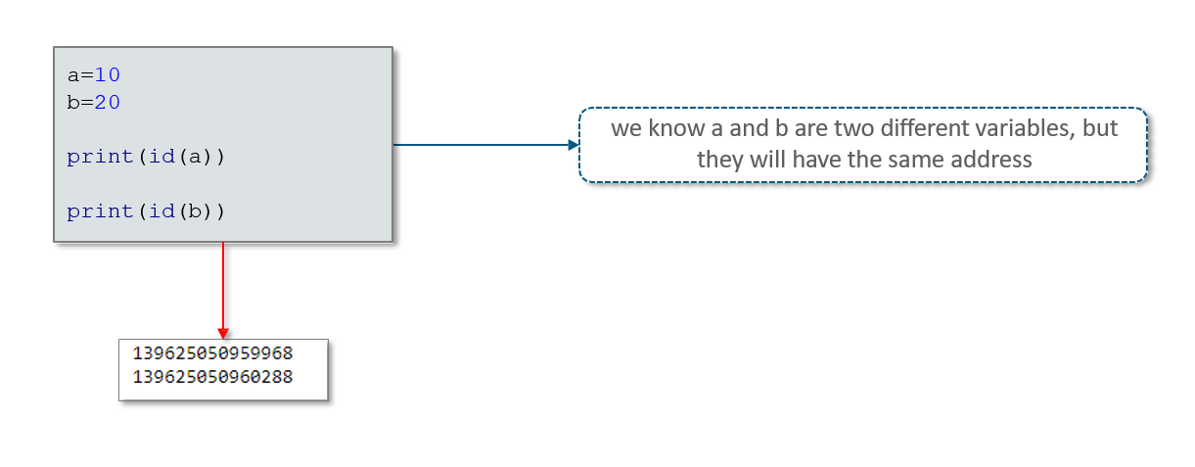

**What are the function arguments in Python?**

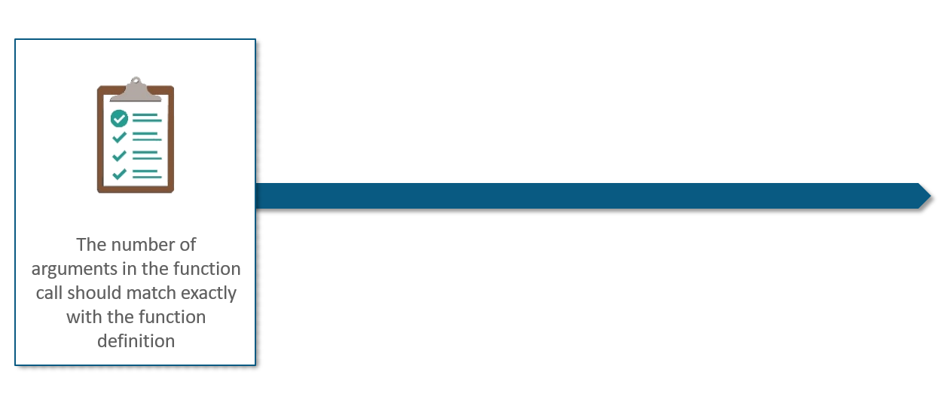

**Example**: **Required Arguments**

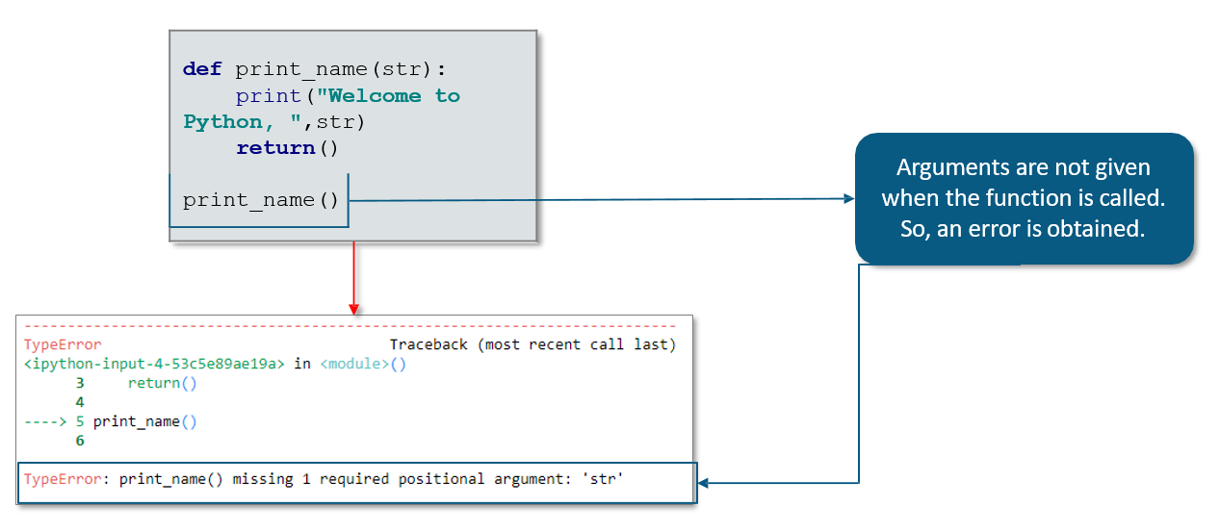

**Keyword Arguments**

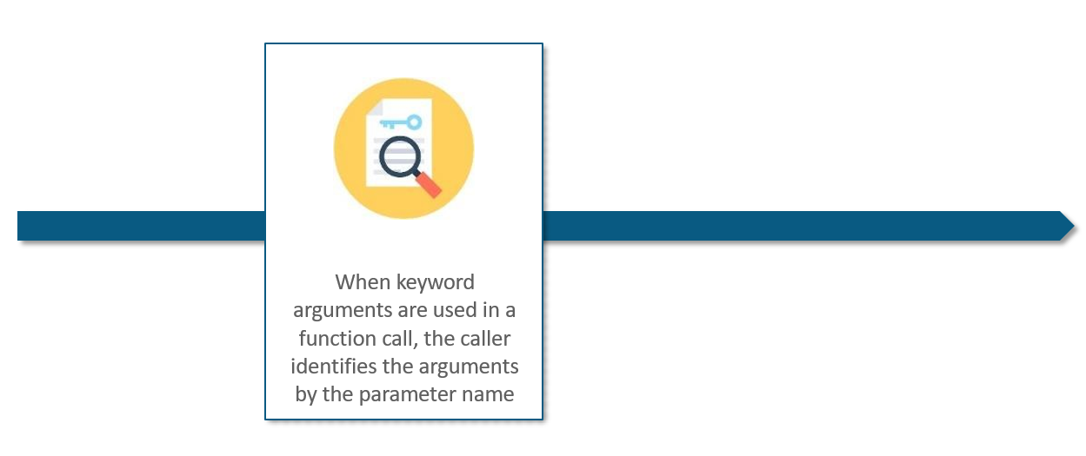

**Example**: **Keyword Arguments**

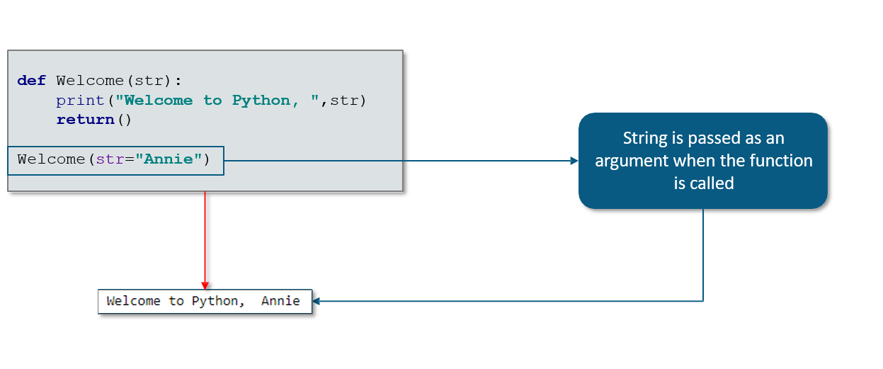

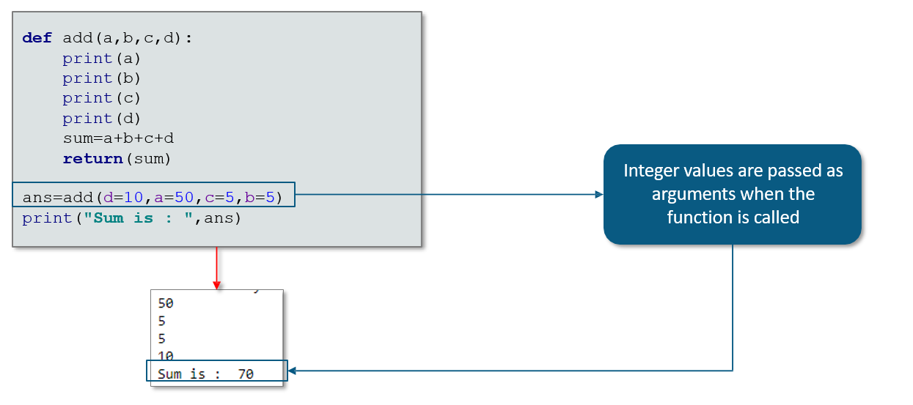

**Default Arguments**

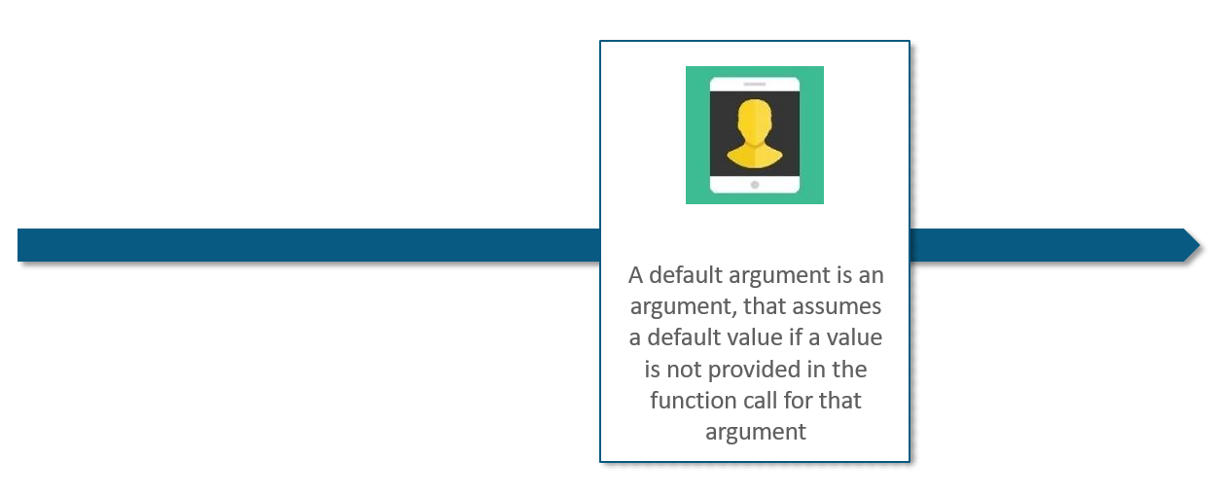

**Example**: **Default Arguments**

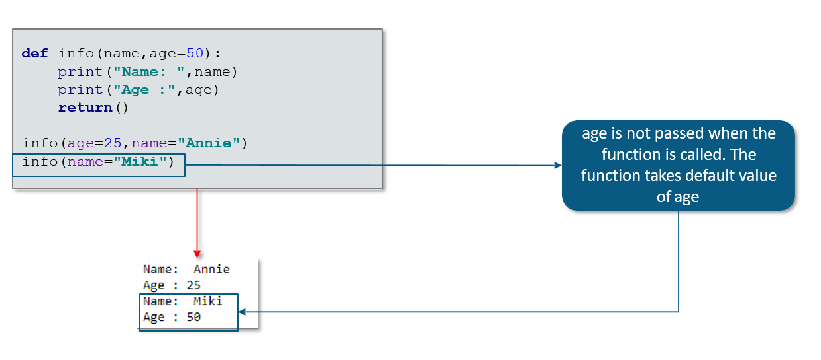

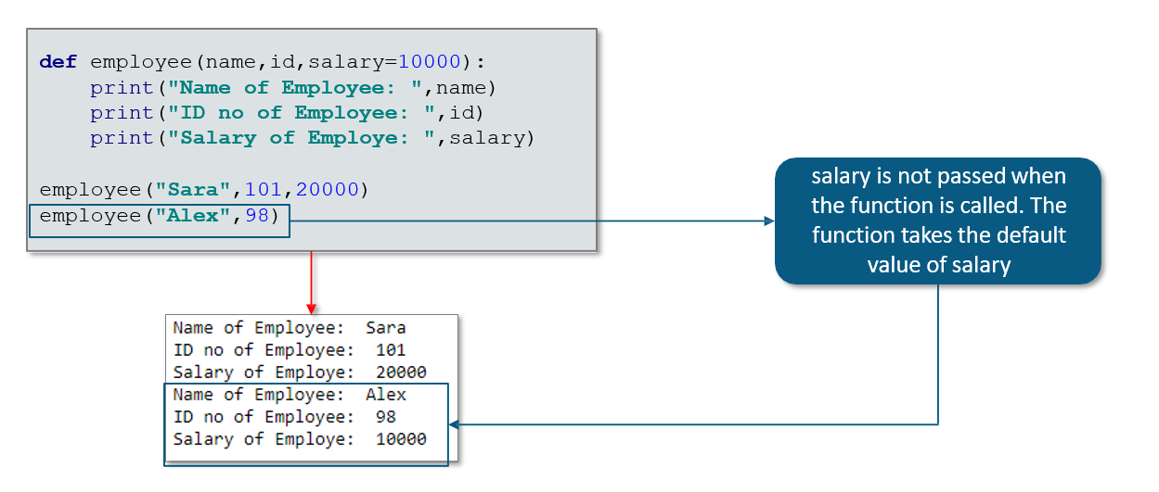

**Variable-Length Arguments**

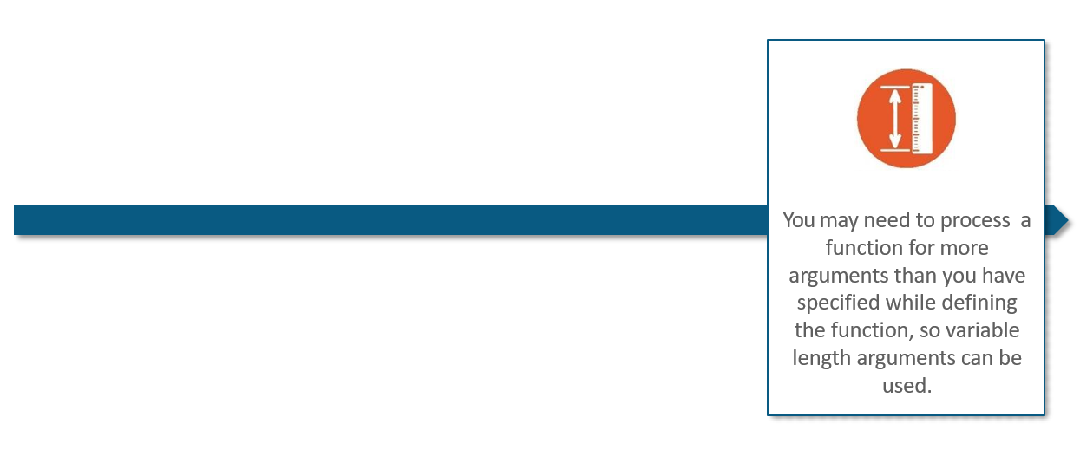

**Example: Variable-Length Arguments**

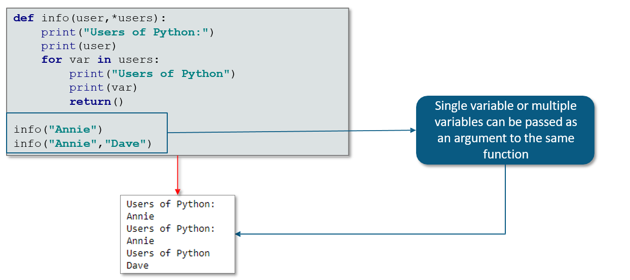

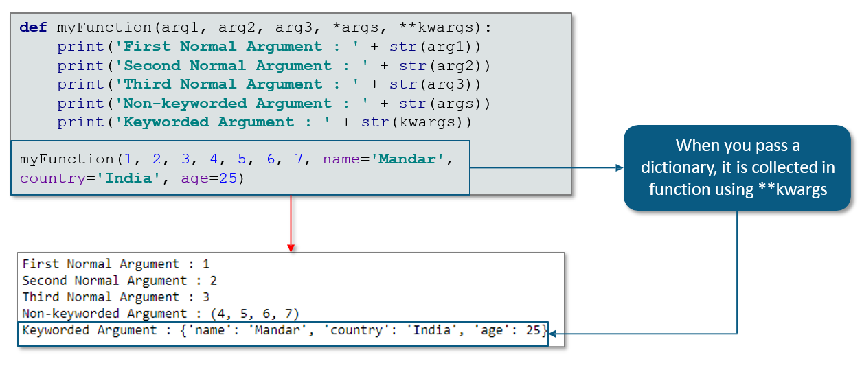

## 8.3 Modules

**What are Modules?**

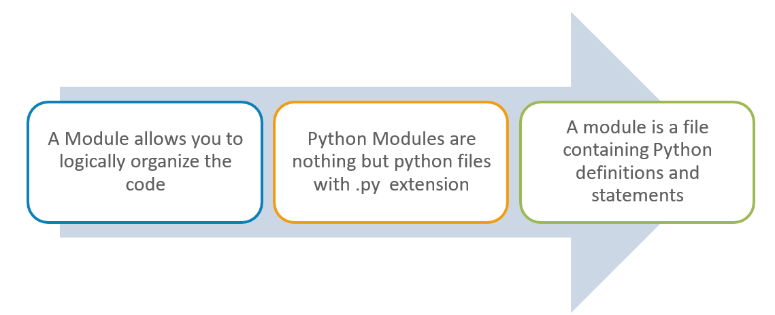

**Usage of Import Statement**

Use “import” to load a module in Python. When the interpreter encounters an import statement, it imports the module, if the module is present in the search path.

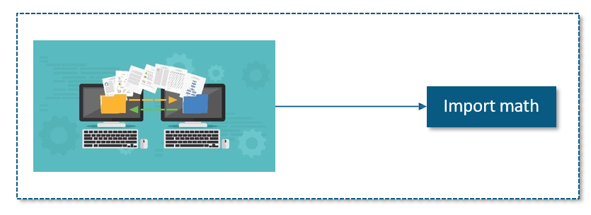

**Dir Function**

A “dir” is a built-in function which returns the list of strings containing the name defined by the module.

It gives the list of variables, functions defined in that module

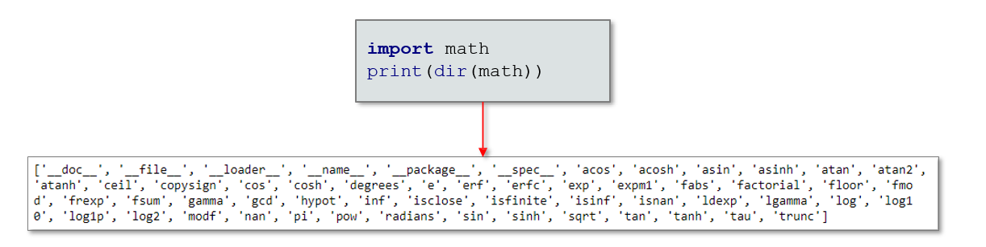

**From Import Statement**

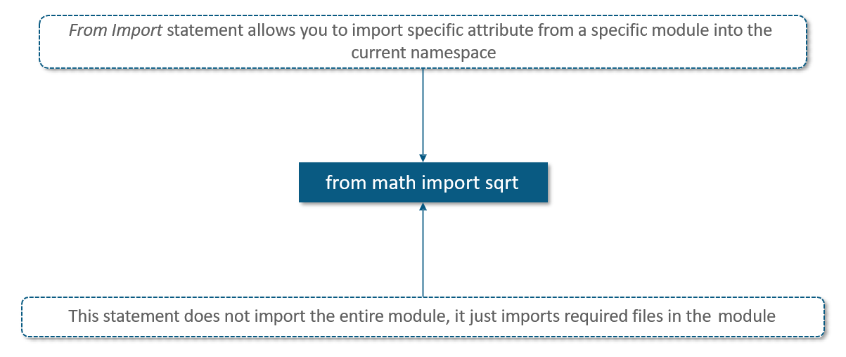

**From Import * Statement**

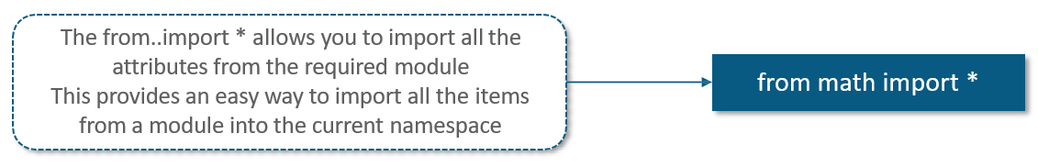

**The Reload Function**

When the module is imported into a script, the code in the top-level portion of a module is executed only once. Therefore, if you want to re-execute the top-level code in a module, you can use the *reload* function. The reload function imports a previously imported module again.

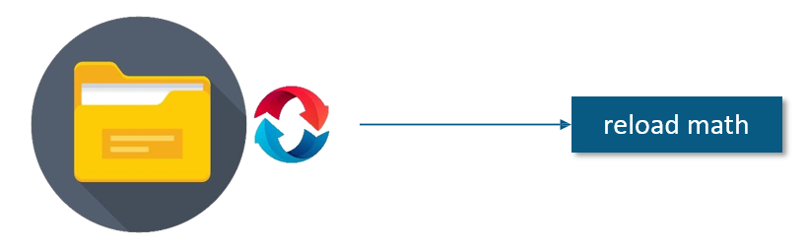

**Important Modules Used in Python**

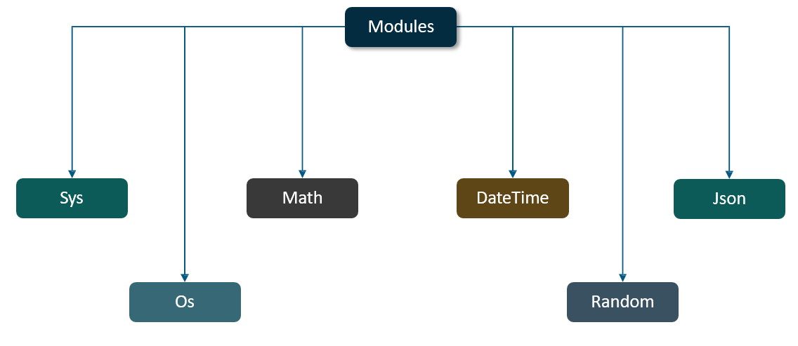

**Sys Module**

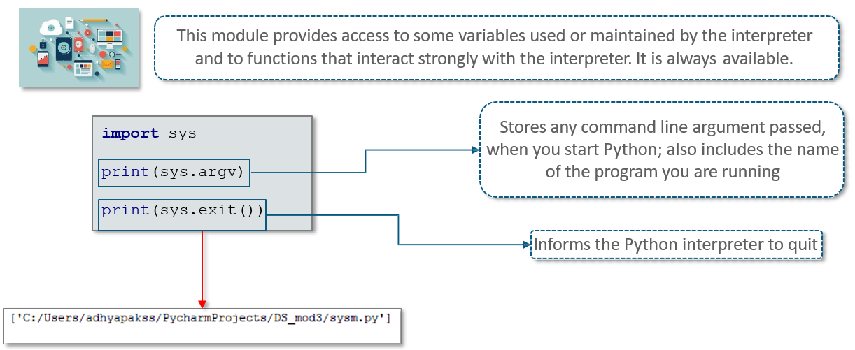

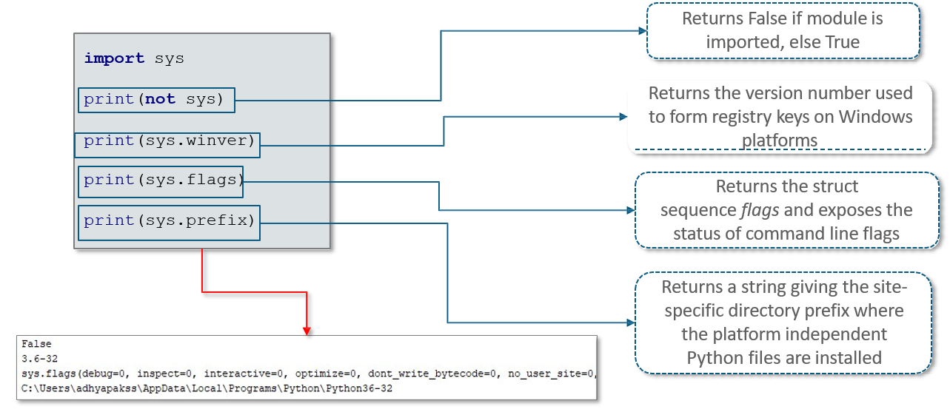

**Os Module**

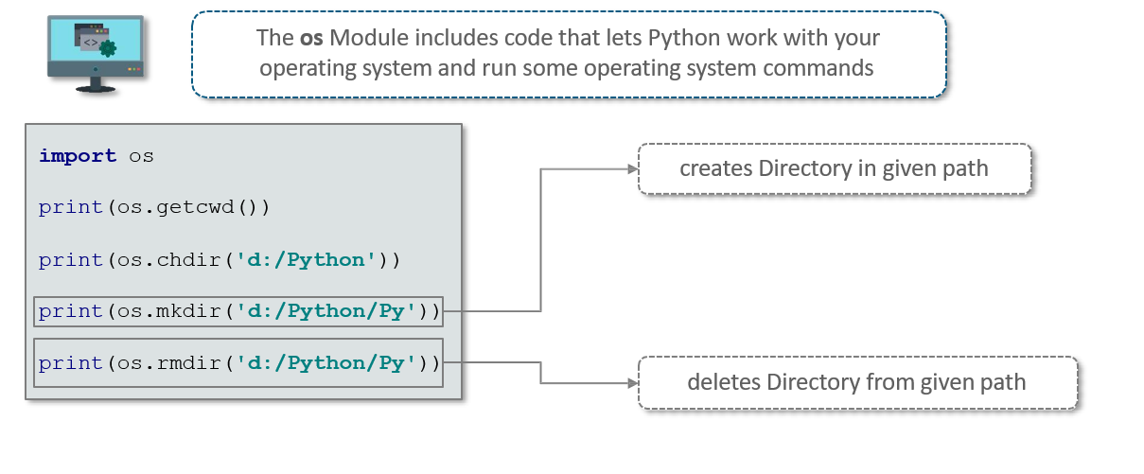

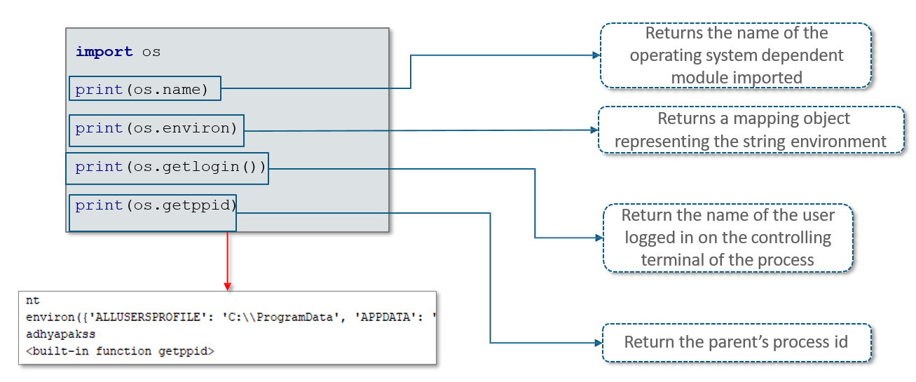

**Os.path Module**

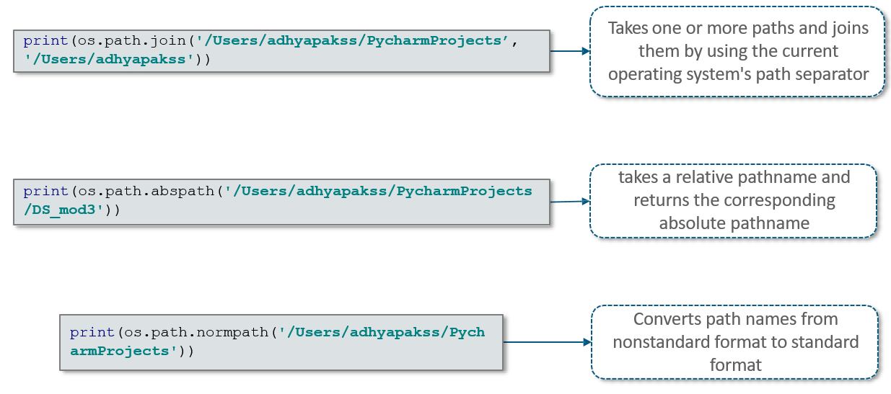

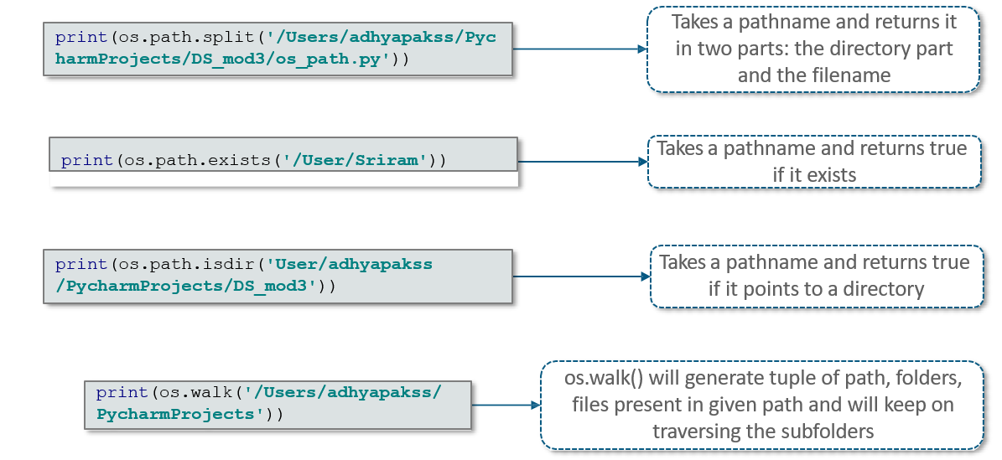

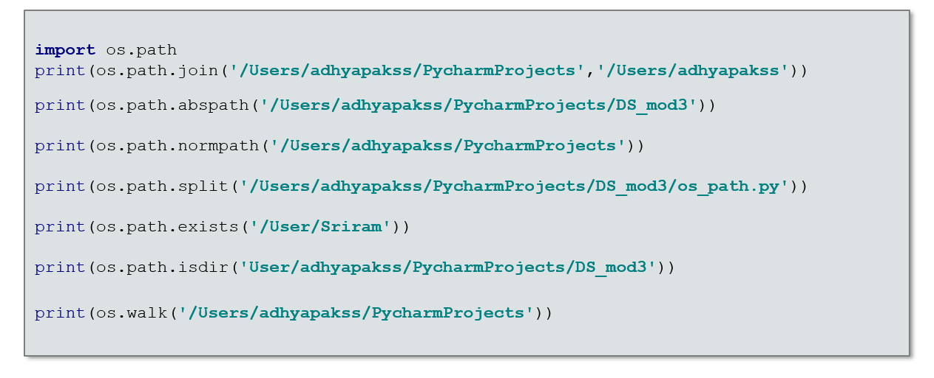

**Math - Theoretic Functions**

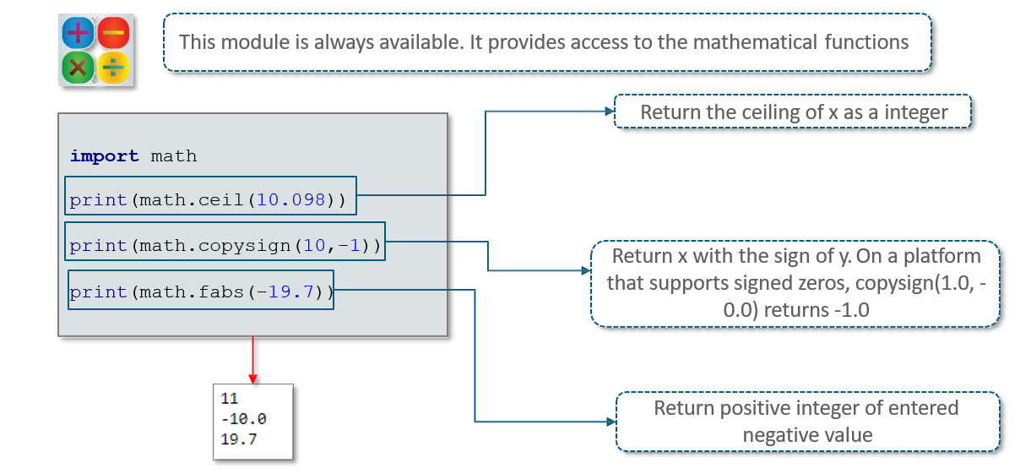

**Math - Power and Logarithmic Function**

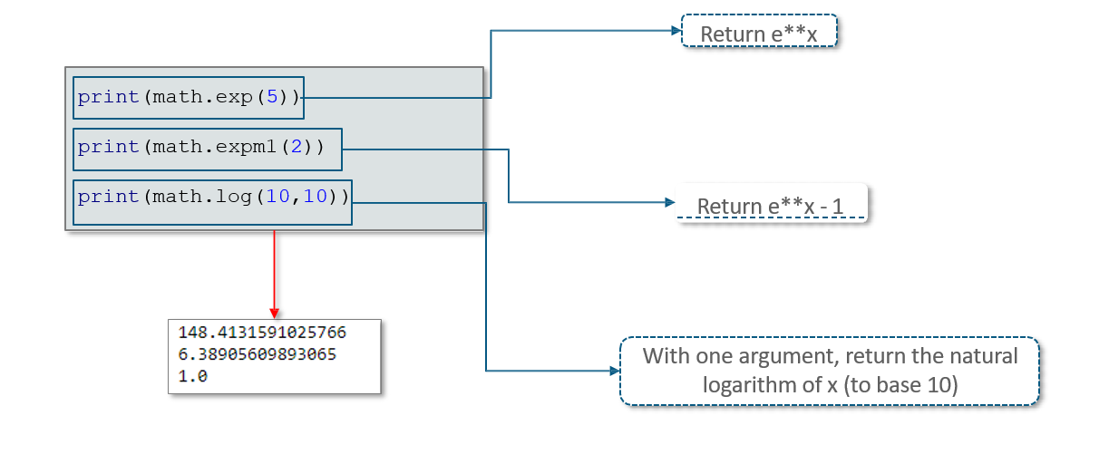

**Math - Trigonometric Function**

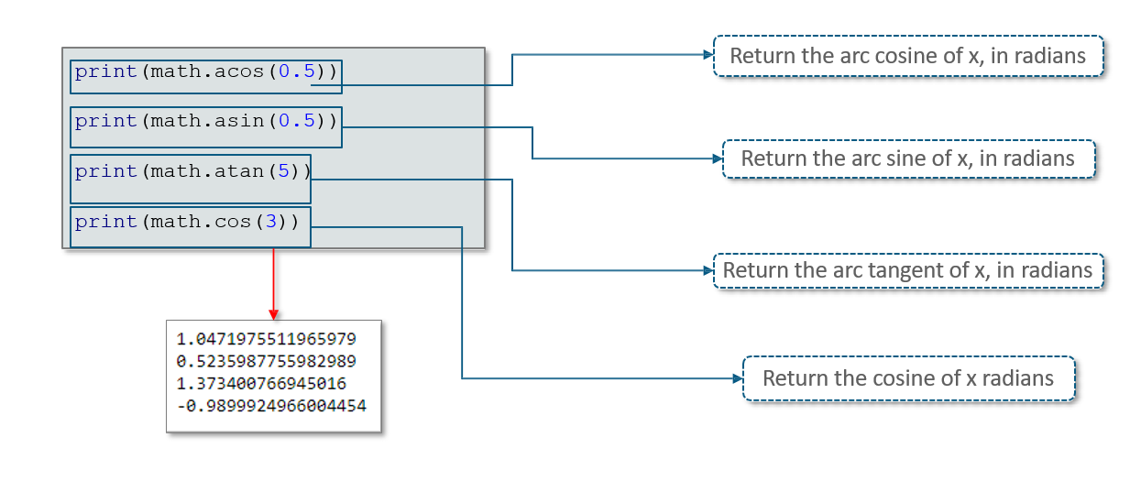

**Math - Angular, Hyperbolic Function**

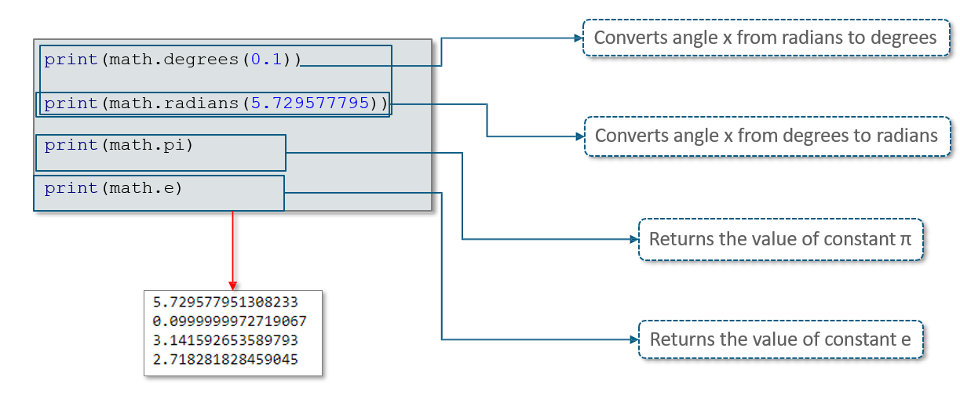

**Random Module**

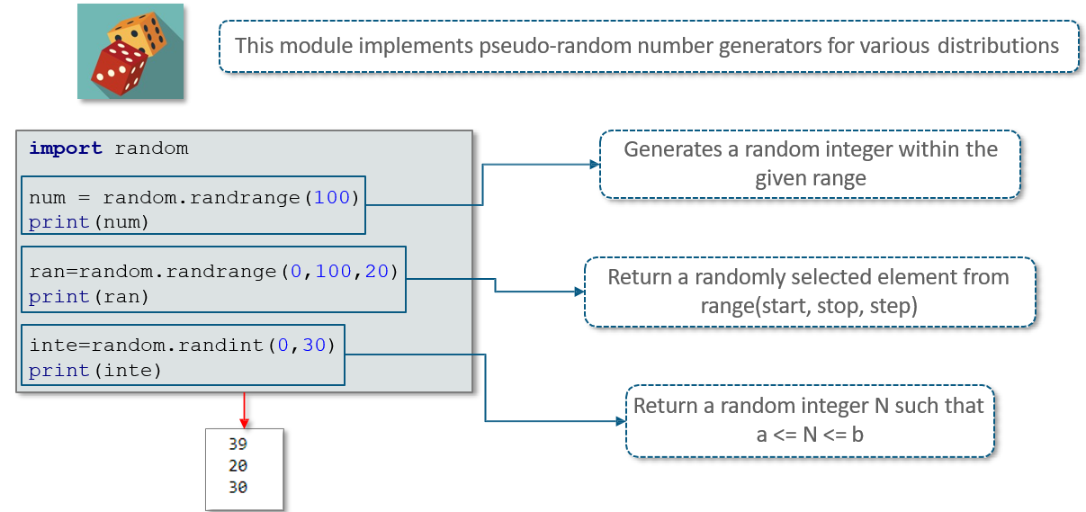

**Random Module..**

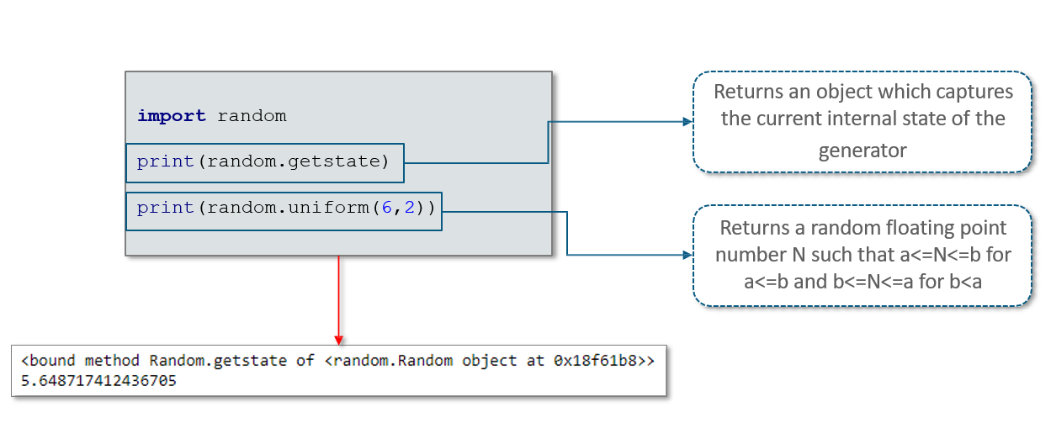

**Random Module- Real Life Application**

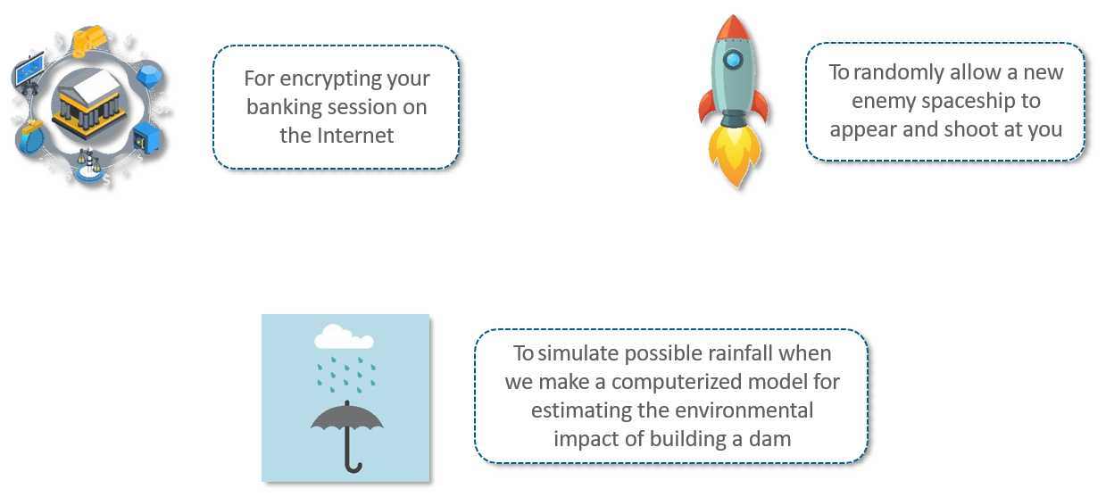

**Date Time Module**

The datetime module includes tools for working with dates, times, and combinations.

The time module includes tools for working with times and dates in the recent past to the near future

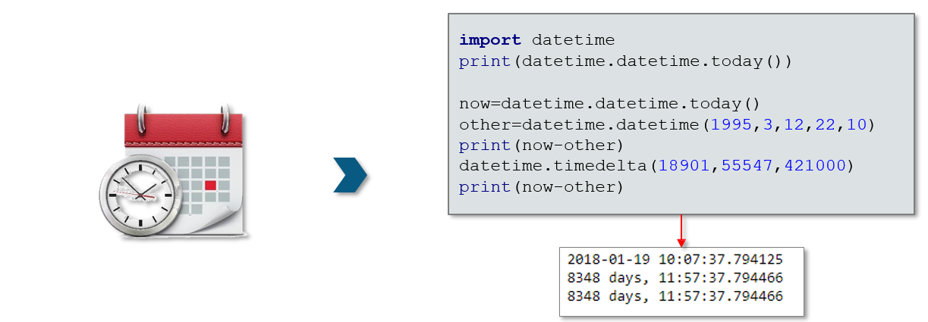

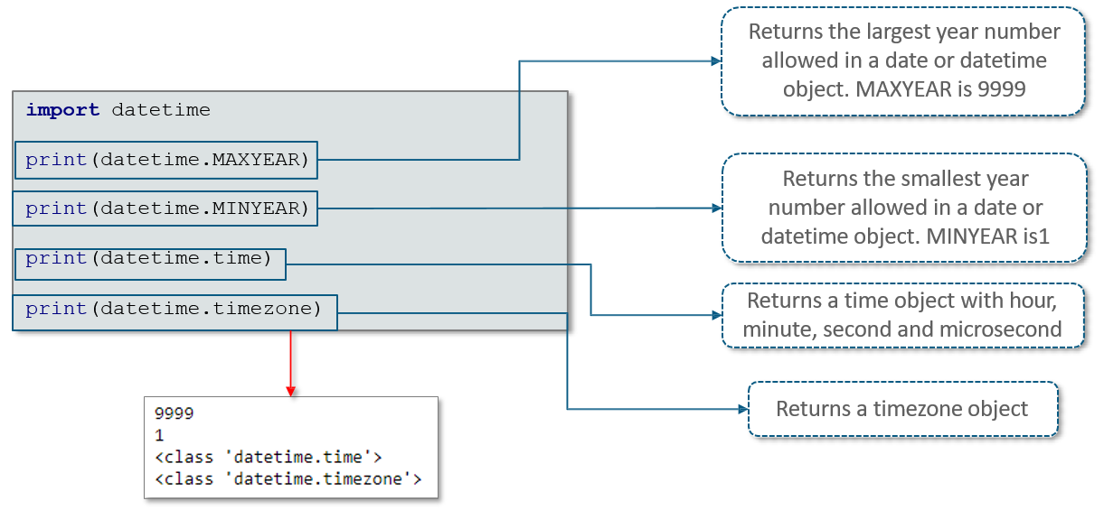

**Json Module**

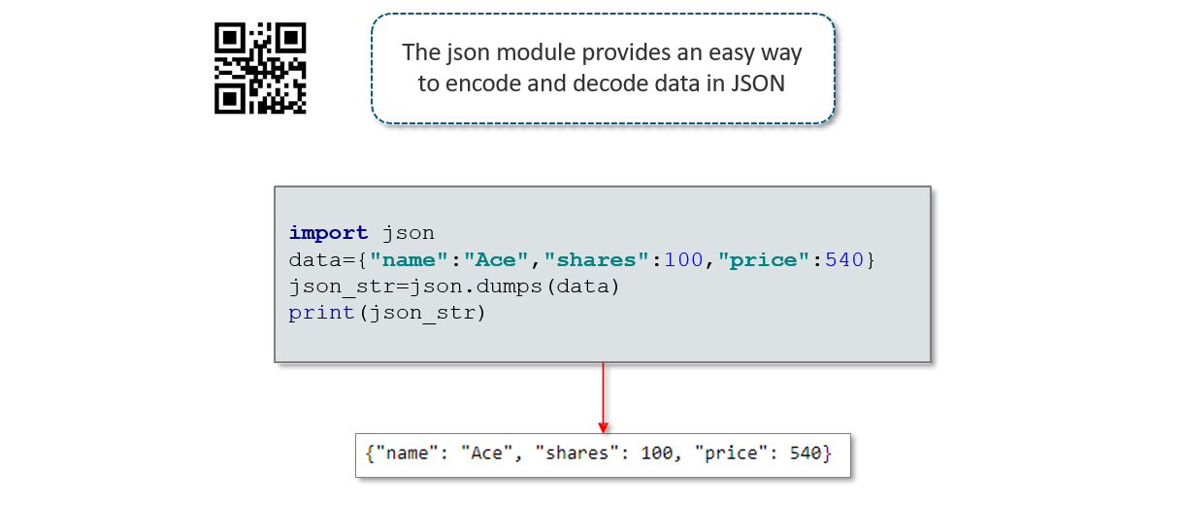

## 8.4 Packages

**What is Package?**

A Package is a collection of Python modules. Python packages allow you to break down large systems and

Organize their modules in a consistent way that you and other people can use and reuse efficiently

